Groundwater Level Forecasting Using Multiple Linear Regression and Artificial Neural Network Approaches

Copyright©2021 by authors, all rights reserved. Authors agree that this article remains permanently open access under the terms of the Creative Commons Attribution License 4.0 International License

Abstract In this paper, two methods are developed for the prediction of groundwater level fluctuation, namely, the Multiple Linear Regression (MLR) and Artificial Neural Networks (ANNs) in Ubung and GOR Ngurah Rai monitoring well for three years (i.e., 2017–2019 and January-October 2015). Simulating groundwater levels prediction using limited hydrometeorological time series data (barometric pressure, evaporation, temperature, wind, bright sunshine, and rainfall) based on the results of previous data screening tests. The screening test is in the form of a trend absence test, stationary, persistence, outlier, and data consistency test. The first method determines the parameters that most significantly influence the groundwater level fluctuation to build a regression model between the predictors and the dependent variable. The second proposed approach is ANNs, where the neural network chosen is the multilayer perceptron that uses the feedforward back-propagation neural network (FFBPNN) as a supervised learning technique for training. The developed model has three-layer structures: one input layer with four and seven neurons, one hidden layer with four, seven, eight, and fourteen neurons and one output layer. Logistic sigmoid (logsig) and linear transfer function (purelin) were used in the hidden and output layers as activation functions. The training algorithm used was gradient descent with momentum and adaptive learning rate (traingdx). The results show that both MLR and ANNs models predict the groundwater level fluctuation at an acceptable correlation coefficient between the actual and predicted groundwater level. However, the ANNs perform better in terms of statistical errors, notably root mean square error (RMSE), mean square error (MSE), and mean absolute error (MAE).
Keywords Groundwater level, prediction, hydrometeorological, multiple regression linear, artificial neural network

1. Introduction
Groundwater is the primary drinking water supply in urban or rural Bali province, particularly in Denpasar City. It is also a vital source of water for agricultural, domestic, and tourism-related industries. The availability of groundwater, the flow of groundwater, and the physical properties of an aquifer or groundwater system are all indicators of groundwater level. Accurate groundwater level forecasting is critical for sustainable groundwater management. Modeling of groundwater fluctuations is intricate because groundwater is concealed and has considerable temporal and spatial variability. Groundwater flow modeling methods exist for several hydrogeological conditions. Data for process-based models that simulate groundwater changes are enormous, complicated, or expensive to gather, combined with limited field data [1, 2].
The principal source of information on hydrological pressures acting on the aquifer is groundwater level readings from observation wells. For long-term groundwater management and protection, systematic water level observations will offer crucial data needed to assess changes in groundwater resources, develop groundwater trend models and forecasts, design, implement, and monitor programs [3]. Groundwater fluctuations are the rise and decrease of groundwater levels caused by natural and human-induced hydrological processes. Understanding these events is critical because multiple mechanisms can function simultaneously, requiring accurate observations. Any change in groundwater pressure will produce differences in groundwater levels. Urbanization, seismicity, hydrometeorology (such as barometric pressure, evaporation, temperature, wind, bright shunsine, and rainfall), tidal influences, and external stress are all factors that induce groundwater level variations [4].
A reliable, simple, and practical method for estimating groundwater level responses is critical for proper groundwater planning and management. So, various simulation and prediction techniques have been developed to prevent mismanagement and over-exploitation of groundwater resources. Simulating groundwater level fluctuations is difficult due to the complexity and non- linearity. These can be affected using several analytical and numerical methods. However, both methodologies have severe flaws when assessing groundwater resources. Analytical approaches are limited to simple hydrogeologic situations. It also requires the derivation of differential equations and intensive computations to generate many s cases. Additionally, constructing numerical models necessitates sophisticated calibration processes that apply rigorous optimization methodologies, which are time-consuming, costly, and uncertain. Empirical models function effectively in these situations because they use simple equations to explain the relationship between elements and do not necessitate a mathematical explanation of the underlying events [5].
Some hydrologists have been interested in using Artificial Neural Network (ANN) tools and statistical techniques such as Multiple Linear Regression (MLR) for predicting or forecasting over the last decade because of their simplicity and profitability. MLR models can simulate the relationship between explanatory and response variables by fitting a linear equation to the observed data [6] and can produce useful findings with less data, less work, and less money [5]. It also allows for the addition of any number of independent variables. Despite their inability to deal with non-linearity between model inputs and outputs, MLR models have been utilized extensively in hydrological investigations due to their simplicity of use and interpretation of parameter relationships [7]. However, the ANN approach is well adapted to modeling non-linear and dynamic systems like water resources systems. The fundamental advantage of ANN over previous techniques is that it does not necessitate detailed mathematical description of underlying processes. After adequate training, ANN models can successfully anticipate various hydrological problems.
Limited studies about MLR application in groundwater level forecasting was reported. Hodgson [8] used MLR to predict water table responses in the South African Vryburg aquifer using rainfall and pumping as input factors and Shao and Campbell [9] utilized regression to model groundwater trends. This is different from the application of ANN in the modeling of groundwater level fluctuations. ANN has been effectively used to predict groundwater levels in unconfined aquifers [1, 10–16]. There were used monthly water-level depth, precipitation, temperature and river-water level, evapotranspiration as inputs to the networks. Uddameri [17] used regression and artificial neural network (ANN) techniques to forecast piezometric levels in a deep well of South Texas using bias, time and dummy variables as inputs to the models and Sahoo and Jha [18] examined the potential of two data-driven approaches, MLR and ANN, for simulating transient groundwater levels in an unconfined aquifer system.
Based on previous research, it is likely that no research has been conducted to date that compares the predictive ability of the MLR and ANN techniques in simulating groundwater levels using limited hydrometeorological time series data (barometric pressure, evaporation, temperature, wind, bright shunsine, and rainfall) based on the results of previous data screening tests. The filtering test is in the form of a trend absence test, stationary, persistence, outlier, and data consistency test. Therefore, the focus of this study is to evaluate the efficacy of two data-driven approaches, such as MLR and ANN, to predict the spatio-temporal distribution of water levels in groundwater basins, using limited hydrometeorological time-series data that have been tested for filtering previously. In this study, the standard MLR and ANN modeling protocols were strictly followed, and selected hydrometeorological data were considered inputs for the model. Thus, this study demonstrates a sound scientific methodology for evaluating two data-driven approaches (modeling tools) in simulating groundwater levels using hydrometeorological data from filtered data.

2. Materials and Methods
2.1. Study Area
The study area is located in the north of Denpasar City, Bali-Indonesia which has an area of 31,42 km² and it lies between 08°35’31” - 08°44’49” south latitude and 115°12’09” - 115°04’39” east longitude [19]. The aquifer in the city of Denpasar, especially the north of Denpasar, is an unconfined aquifer with a shallow groundwater level and this aquifer is a with flow through fissures and spaces between grains and is a highly productive aquifer [20]. This aquifer is part of the Denpasar-Tabanan groundwater basin [21]. Denpasar is the region covered by volcanic sediments and generally, alluvium and young volcanic sediments are highly permeable, and lower quaternary and tertiary sediments have wide-ranging permeability due to the formation. Denpasar as a part of Bali island consists of Miocene to Pliocene volcanic products and marine sediment as basement rock, overlain by a thick pyroclastic flow, volcanic products and volcanic mudflow that originated from intensive volcanic activities in The Pleistocene to Holocene of Quaternary period [22]. Figure 1 shows the location of the study area.
2.2. Data Collecting
The Bali Province Department of Manpower and Energy and Mineral Resources provided general groundwater data on geography, geology, topography, and hydrogeology. The Bali-Penida River Basin Department and the Meteorological, Climatological, and Geophysical Agency III Bali Province also provided hydrometeorological data. The Polygon Thiessen method was used to convert point rainfall data to area rainfall.

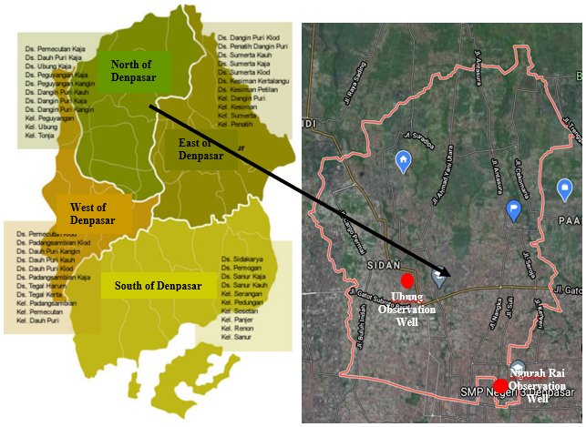
Figure 1. Location of study

The hydrometerology data adjusts to the availability of groundwater level data, which is only available for 3 years. The study used hydrometeorological and water table data from January 2017 to December 2019 and January to October 2015. Monthly hydrometeorological and groundwater-level data for the 3-year period 2017–2019 were used for training (calibration) of the 2 observation wells for MLR and ANN models, with the 10-month period January to October 2015 being used for testing (verification). Table 1 shows the location of each well.
Table 1. Position of observation well
 | Well Number | Coordinate
Ubung | SP No. 04/DP/Distam | 08° 43’ 56,3” LS; 115° 10’ 36,4” BT
Ngurah Rai | SP No. 02/DP/Distam | 08° 39’ 05,0” LS; 115° 13’ 23,6” BT
2.3. Hydrometeorology Data Testing
Hydrometeorological data is a sequence of time sequence data that must be tested first before being used in the analysis. Hydrometeorological data in this study are data on rainfall, evaporation, humidity, bright sunshine, temperature, wind speed, and air pressure coupled with data on groundwater level fluctuations. This testing phase can also be called data screening, to examine and sort or group data, aiming to obtain hydrometeorological data reliable enough for analysis so that the conclusions obtained are good enough [23]. The hydrometeorology data test is a consistency test, trend absence test, outlier test, stationary, and persistence test.
2.3.1. Consistency Test
To see the principality in a series of data obtained, a data consistency test is required. The method used in this test is the Rescaled Adjusted Partial Sums (RAPS) method. This test compares the results of calculations of statistical values Q and R with critical values. If the critical value is greater than the calculated value, the data is received and vice versa.
2.3.2. Trend Absence Test
This test is done to find out the number or absence of trends from periodic series data. To test the lack of trends used the Spearman Method's Statistical Correlation Ranking Method. This approach is a correlation between time and variant from a table of hydrological variables [23].
2.3.3. Outlier Test
An abnormality test or outlier test is used to determine whether the maximum and minimum data from an existing data set is worth using or not [24]. This test is based on data deviating from two thresholds, namely the lower and upper threshold, to be eliminated or adjusted to the threshold value.
2.3.4. Stationary Test
The stability of variant values and averages of a time series in this study is hydrometeorology data can be seen with stationary tests. This study will conduct a stationary test with variant stability test (F-Test) and average stability test (t-Test). Suppose the calculated value is greater than the critical value. In that case, the data tested does not come from the same population or is not stationary at a certain significance level. Variant values are unstable and un homogeneous if test results show the null hypothesis is rejected [23].
2.3.5. Persistence Test
Persistence tests in this study are used as a requirement in frequency analysis by testing the absence or absence of dependence on each data. If there is no dependency on each value, then the data can be used in frequency analysis. The magnitude of the correlation coefficient needs to be taken into account [23].
2.4. Modelling
Based on the hydrometeorological data testing, new variables were identified. These variables were used in modelling using multiple linear regression (MLR) and Artificial Neural Network (ANN).
2.4.1. Multiple Linear Regression (MLR)
Multiple linear regression (MLR) expresses the linear connection between a dependent variable and several independent variables [8][25]. Also termed predictand, dependent variable, and predictors. MLR uses least squares to fit the model, minimizing the sum of squares of observed and predicted values. MLR can be expressed as (1)
(1)
where Y means dependent variable, Xi means independent variables, βi means predicted parameters, and ε is the error term.

2.4.2. Classic Assumption Test
Determining the value of Y (independent variable) to estimate the value associated with X as an dependent variable is necessary for estimating cause-and-effect relationships. So, the essence of regression analysis is to explain and test the relationship between one or more independent variables into one dependent variable. Multiple regression methods can be an unbiased estimation tool if it meets Best Linear Unbiased Estimation (BLUE) requirements. Before the hypothetical test and to meet BLUE needs, the first classic assumption test is done. Classical assumptions will comprise: multicollinearity test, normality test, autocorrelation test and heteroscedasticity test [26].
The normality test checks whether dependent and independent variables in regression have a normal distribution. A good regression model is a data that is normally distributed or close to normal. Multicollinearity arises when all or some of the independent variables in a regression model are perfectly linear. The multicollinearity test checks whether the regression model found an independent variable correlation (independent). A decent regression model does not correlate with the variables. Durbin Watson statistical tests to find a serial correlation (Autocorrelation) in time series data. Serial correlation is a situation where there is a relationship or correlation between two observations for a variable. The heteroscedasticity test checks whether the residual variance of one observation differs from another in the gradient model. The variance of one residual observation remains the same, while the variance of another is heteroscedastic. A decent regression model has homoscedasticity [26].

2.4.3. Artificial Neural Network (ANN)
The human brain is a nonlinear, complex, and parallel computer [27]. The basic anatomy of the human brain-inspired ANN [28]. An ANN is made up of simple, highly interconnected processing components, like neurons. A model is a black box of equations that calculate output based on input values [29]. Figure 2 shows a block schematic of a neuron model for creating an ANN [27].
According to Haykin [27], we may mathematically describe a neuron k as follows
(2)
(3)
Bias, meant by b_{k}, has the effect of increasing or lowering the net input of the activation function. x₁, x₂, ..., x_{m} are the inputs; w_{k1}, w_{k2}, ..., w_{km} are the weights of the neuron k; u_{k} is the linear combiner output due to input signals; φ is the activation function; y_{k} is the output signal of the neuron.
Backpropagation is a popular ANN learning algorithm in multilayered feedforward networks. Backpropagation networks process data from input to hidden layer to output layer. Finding optimal weights is the goal to get close to targets [27].
Feedforward backpropagation neural network (FFBPNN) architecture was used in this research, along with gradient descent with momentum and adaptive learning rate backpropagation (traingdx) for training algorithms, to find the best algorithm for predicting groundwater levels over the study field. In the hidden layer, logistic sigmoid non-linear function (logsig) and output layer, linear transfer function (purelin) was used as an activation function.

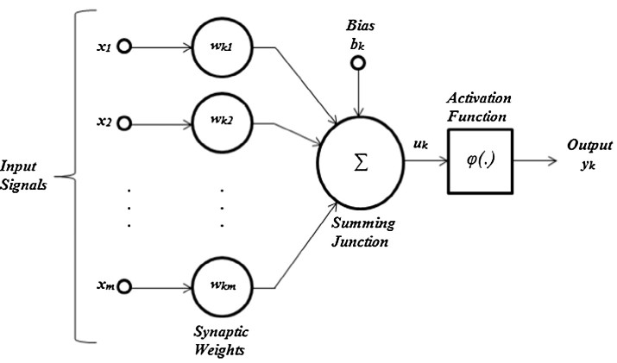
Figure 2. Block diagram of model of a neuron

2.4.4. Model Performance
The quantitative performance of MLR and ANN models was judged by using five statistical metrics (goodness-of-fit criteria): correlation coefficient (R), coefficient determination (R²), root mean squared error (RMSE), mean squared error (MSE), and mean absolute error (MAE).

3. Results and Discussion
3.1. Data Quality Test
Before the analysis to get a model of groundwater level fluctuations, available meteorological data need to be tested statistically hydrologically [23]. In this study, data quality testing used outlier tests or abnormality tests, trend absence tests, persistence tests, stationary tests, and consistency tests. The test results can be seen in the Table 2. Based on the data quality test, three data are eliminated: humidity data, bright sunshine, and wind speed data that are not used in subsequent analysis.
Generation or prediction of groundwater level fluctuation data to extend the data of groundwater level fluctuations using data on groundwater level fluctuations at Ubung and GOR Ngurah Rai monitoring wells. The use of the two monitoring wells is based on the position of the appropriate well to represent fluctuations in groundwater levels in the area of groundwater addition in the Denpasar city aquifer. The best model for predicting groundwater level fluctuations used in this study is based on comparing Multiple Linier Regression and Artificial Neural Networks.

Table 2. Hydrometeorology Data Quality Testing Recapitulation
Data | Data Quality Test

 | Outlier | Consistency | Trend Absence | Persistence | Stationary | Information
Evaporation | No outlier | Consistent | Independent | Independent | Stable | Ok
Barometric pressure | No outlier | Consistent | Independent | Independent | Stable | Ok
Temperatures | No outlier | Consistent | Independent | Independent | Stable | Ok
Humidity | No outlier | Consistent | Dependent | Independent | Unstable | Not Ok
Wind speed | No outlier | Consistent | Independent | Independent | Unstable | Not Ok
Bright sunshine | No outlier | Consistent | Dependent | Independent | Stable | Not Ok
Rainfall (rain gauge Ngurah Rai) | No outlier | Consistent | Independent | Independent | Stable | Ok
Rainfall (rain gauge Sanglah) | No outlier | Consistent | Independent | Independent | Stable | Ok
Rainfall (rain gauge Sumerta) | No outlier | Consistent | Independent | Independent | Stable | Ok
Rainfall (rain gauge Kapal) | No outlier | Consistent | Independent | Independent | Stable | Ok
Rainfall (rain gauge Buagan) | No outlier | Consistent | Independent | Independent | Stable | Ok
Rainfall (rain gauge Sading) | No outlier | Consistent | Independent | Independent | Stable | Ok
Rainfall (rain gauge Penatih) | No outlier | Consistent | Independent | Independent | Stable | Ok

3.2. Multiple Linier Regression
The prediction model with the Multiple Linear Regression approach produces the following equations:
Ubung monitor well equation model:
(4)
Model of equation of monitor well GOR Ngurah Rai:
(5)
Both models were obtained through several stages of analysis, namely having qualified data normality for three years (all normally distributed parameters) based on the Kolmogorov-Smirnov test and the Shapiro-Wilk test where all data has a Sig. > 0.05 value. The accuracy of the regression function in estimating the actual value can be measured from its Goodness of fit. Statistically, at least this can be measured from the value of the coefficient of determination (R²), the statistical value F and the statistical value t.
Regression models at Ubung monitor wells produce a coefficient of determination (R²) value of 0.606 which means that 60.6% of groundwater level can be explained by parameters of barometric pressure (BP), evaporation (E), temperature (T), and precipitation (P). In contrast, the rest is explained by other variables, which are estimated to be due to the exploitation of groundwater by the community. Based on simultaneous tests, obtained value F_{count} = 11.905 with probability (Sig.) 0.000 (< 0.05) which indicates that there is an influence or contribution between variables of barometric pressure, evaporation, temperature, and precipitation simultaneously and significantly to fluctuations in groundwater levels so that regression models on Ubung monitoring wells can be used to predict changes in groundwater levels. Based on partial or individual tests, the Sig value of precipitation is worth 0.361 (0.361 > 0.05), which means no significant relationship between precipitation parameters and fluctuating groundwater levels. In contrast, other parameters (barometric pressure, evaporation, and temperature) have a partially meaningful relationship to fluctuating groundwater levels. Linear regression models are called good models when they meet some assumptions, better known as classical assumptions. The classic assumptions that must be met are normally distributed residuals, no symptoms of multicollinearity, no heteroskedasticity, and no signs of autocorrelation. The classical assumption test analysis results showed that the regression model for the Ubung monitor well met the entire classical assumption test. In general, the groundwater level fluctuation model could be used with unbiased estimation. To test the regression model that has been built, a calibration test based on data for 36 months (2017-2019) and a verification test for ten months data (January - October 2015) with statistical parameters Root Mean Square Error (RMSE), Mean Square Error (MSE), Mean Absolute Error (MAE), and Correlation Coefficient (R). An MSE value of 0.6325 is obtained; RMSE of 0.7953; MAE of 0.6122; and the R-value of 0.7783. The smaller the MSE, RMSE, and MAE values show, the better the predicted value and based on the value of R between the observation groundwater level (GWL) value and the prediction GWL, there is a strong relationship because the value of R is between the value range of 0.600 - 0.799 [30]. Unlike the calibration process where the MSE value is 1.6415; RMSE of 1.2812; MAE value of 0.8384 which means between the observation GWL value and the prediction GWL has a fairly high error rate. The R-value in the calibration process is only 0.3132, which means the correlation rate of the observation GWL with the prediction GWL is low. Figure 3 shows the comparison between the GWL observation and prediction at the calibration stage, and Figure 4 at the verification stage in Ubung observation well.
The regression model at GOR Ngurah Rai monitoring well produces a coefficient of determination (R²) value of 0.257. Only 25.7% of groundwater level can be explained by barometric pressure, evaporation, temperature, and precipitation. In comparison, the rest (74.3%) is defined by other variables. In this case, it is estimated that the exploitation of groundwater by the community where the position of aquifers in the GOR Ngurah Rai area is quite shallow, namely 15-20 meters below the face soil. Based on simultaneous tests, obtained value F_{count} as much as 2.685 with a smaller probability equal to 0.05, which indicates that there is an influence or contribution between variables of barometric pressure, evaporation, temperature, and precipitation simultaneously and significantly to fluctuations in groundwater levels so that regression models on GOR Ngurah Rai monitoring wells can be used to predict changes in groundwater levels. Based on the partial test or individual test (t-test), the Sig value of barometric pressure and precipitation is greater than 0.05 (Sig. > 0.05), which means there is a significant partial relationship between barometric pressure and precipitation parameters with fluctuating groundwater levels. In contrast, other parameters (evaporation and temperature) do not have a partially important relationship to fluctuating groundwater levels. The analysis of classical assumption tests on the GOR Ngurah Rai monitoring well showed that the model met all classical assumption testing. In general, the GWL model could be used with unbiased estimation. To test the regression model that has been built, a calibration test based on data for 36 months (2017-2019) and a verification test for ten months data (January - October 2015) with statistical parameters RMSE, MSE, MAE, and R value. In the calibration process, an MSE value of 0.3740 is obtained; RMSE of 0.6116; MAE of 0.4717; and the R-value of 0.5072. The smaller the value of MSE, RMSE, and MAE shows the better the predicted value and based on the value of R between the value of the observation GWL and the prediction GWL, there is a medium relationship because the value of R is between the range of values 0.400 - 0.599 [30]. Unlike the calibration process where the MSE value is 1.3406; RMSE of 1.1579; MAE value of 0.9152 which means between the observation GWL value and the prediction, GWL has a fairly high error rate. The R-value in the calibration process is obtained at -0.2140, which means the correlation rate of the observation MAT with the prediction MAT is low value and has the opposite relationship. Figure 5 shows the comparison between the GWL observation and prediction at the calibration stage, and Figure 6 at the verification stage in GOR Ngurah Rai observation well.

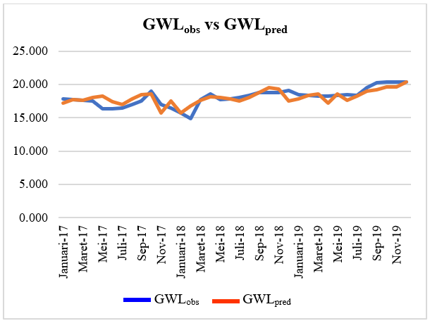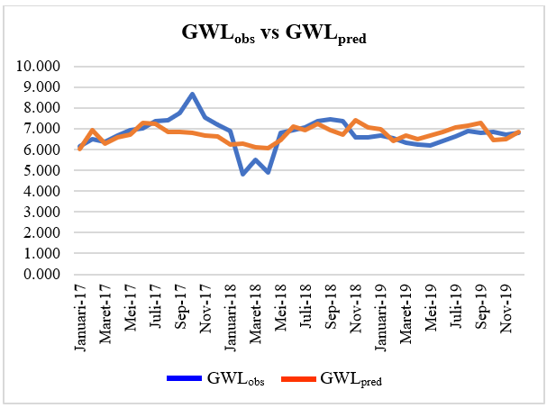
Figure 3. GWL_{obs} and GWL_{pred} in calibration stage (Ubung) Figure 5. GWL_{obs} and GWL_{pred} in calibration stage (GOR Ngurah Rai)
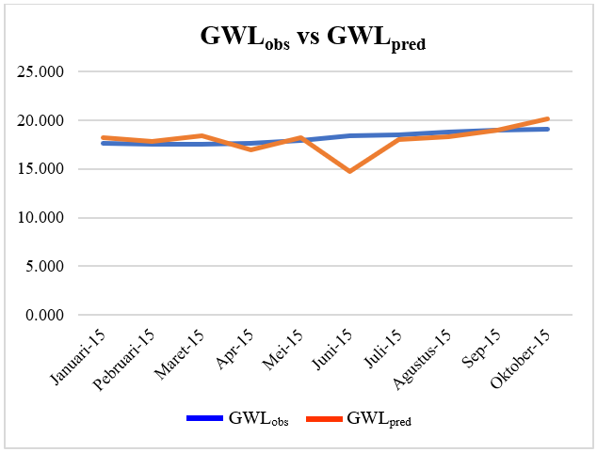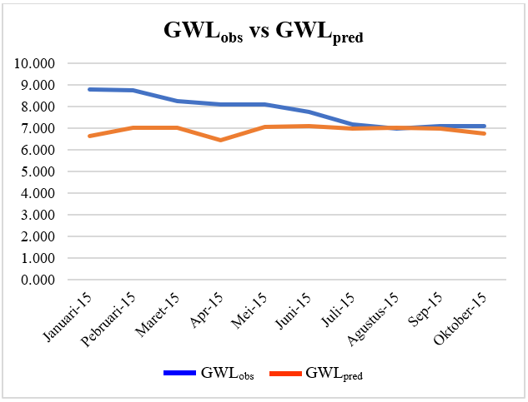
Figure 4. GWL_{obs} and GWL_{pred} in verification stage (Ubung) Figure 6. GWL_{obs} and GWL_{pred} in verification stage (GOR Ngurah Rai)

3.3. Artificial Neural Network
Modeling of groundwater level fluctuations in the aquifer area in Denpasar City aquifer using four variations of network architecture, namely 4-4-1 architecture (4 input variables – 4 neurons hidden layer – 1 output variable); architecture 4-8-1 (4 input variables – 8 hidden layer neurons – 1 output variable); architecture 7-7-1 (7 input variables - 7 hidden layer neurons) - 1 variable output); and 7-14-1 (7 input variables – 14 hidden layer neurons – 1 output variable). Variations of network architecture can be seen in Figure 7 and Figure 8.

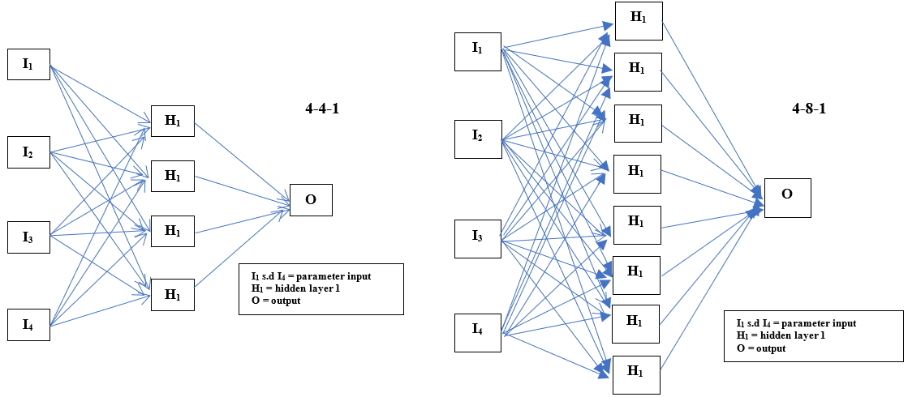
Figure 7. Variations of network architecture (4-4-1 and 4-8-1)

The selection of input parameters for the ANN model is based on previous studies using parameters of barometric pressure, evaporation, temperature, humidity, wind speed, bright sunshine, and groundwater level fluctuation data (GWL), but the use of input parameters is used partially [31]. In this study, input parameters in the form of hydrometeorological variables, including barometric pressure, evaporation, temperature, humidity, wind speed, and bright sunshine data, will be used simultaneously as variations of network architecture. Another variation is to use hydrometeorological input parameters based on data quality test results where the selected parameters are barometric pressure, evaporation, temperature, and precipitation. The data used are hydrometeorology and GWL data for 36 months (2017 - 2019), used as calibration and hydrometeorology and GWL data for eight months (January - October 2015) as verification data.
Modelization of groundwater level fluctuations with ANN approach is done with the help of Matlab R2015a software to facilitate and accelerate analysis to get a prediction model on the Ubung monitoring well and GOR Ngurah Rai monitoring well as an observation well for the groundwater addition area in Denpasar city aquifer. The stages of analysis with the ANN approach are to perform the process of normalization.

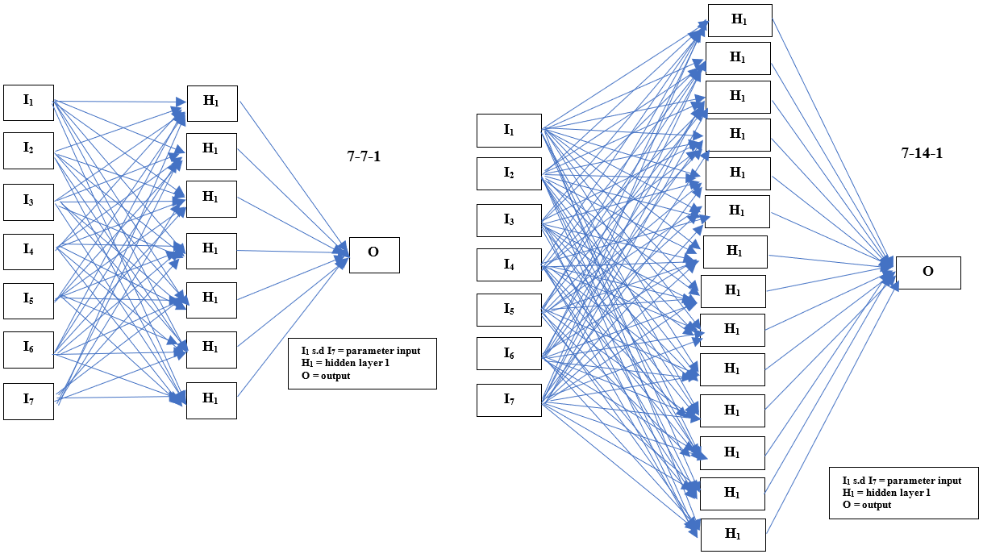
Figure 8. Variations of network architecture (7-7-1 and 7-14-1)

or preprocessing data or data transformation following the range of activation functions applied, the process of input data training and data testing into the network architecture (4-4-1; 4-8-1; 7-7-1; and 7-14-1), conducting the analysis process until it obtains the most optimal results based on the mean value of square error. (MSE) network and correlation coefficient value (R) stage training, testing, and validation of the overall variation of the ANN model. Obtained a different ANN model for each monitoring well, the equation obtained is:
Equation of ANN model of Ubung monitor well:
(6)
Equation of ANN model GOR Ngurah Rai monitor well:
(7)
The ANN model for Ubung monitor wells uses a network architecture of 4-4-1 (4 input variables – 4 hidden layer neurons – 1 output variable). The MSE model value of 0.0018388 in the 87th epoch with an overall R_{model} value of 0.95493. Based on the results of calibration tests (training) obtained a value of R = 0.955; R² = 0.912; MSE = 0.143; RMSE = 0.379; and MAE = 0.311 and based on the results of the verification test (testing) obtained the value R = 0.891; R² = 0.794; MSE = 0.129; RMSE = 0.359; and MAE = 0.319. The 7-14-1 network architecture also provides good value in modelling groundwater level fluctuations in Ubung monitor wells. It can be seen from the R_{training} value of 0.9674 and the R_{testing} value of 0.7635, which means it has good reliability in modelling fluctuations in groundwater levels. These values show the reliability of the ANN model with an architecture of 4-4-1 or 7-14-1 as a model for predicting fluctuations in groundwater levels in Ubung monitoring wells. Figure 9 shows the comparison between the GWL observation and prediction at the calibration stage, and Figure 10 at the verification stage in Ubung observation well.
The ANN model for GOR Ngurah Rai monitoring wells uses a network architecture of 7-14-1 (7 input variables – 14 hidden layer neurons – 1 output variable). The MSE model value of 0.0010372 in the zero epoch with an overall model R-value of 0.95568. Based on the results of calibration tests (training) obtained a value of R = 0.9557; R² = 0.9133; MSE = 0.0483; RMSE = 0.2198; and MAE = 0.1266 and based on the results of the verification test (testing)obtained the value R = 0.2227; R² = 0.0496; MSE = 0.6621; RMSE = 0.8137; and MAE = 0.5985. These values show the ANN model with a 7-14-1 architecture has the ability as a model to predict fluctuations in groundwater levels at the GOR Ngurah Rai monitoring well. Figure 11 shows the comparison between the GWL observation and prediction at the calibration stage, and Figure 12 at the verification stage in GOR Ngurah Rai observation well.
The relationship between the GWL_{observation} and the GWL_{prediction} the results of the modelization of ANN with the network architecture 4-4-1 at the Ubung monitoring well, resulting in a correlation coefficient (R) of 0.955 and a coefficient of determination (R²) of 0.912 at the calibration stage (training) and 0.891 coefficient of determination (R²) of 0.794 at the verification stage (testing). Which means it has a very strong correlation. While the relationship between GWL_{observation} and the GWL_{prediction} the results of the modelization of ANN with the network architecture 7-14-1 at GOR Ngurah Rai monitoring well produces a correlation coefficient (R) of 0.9557 and coefficient of determination (R²) of 0.9113 at the calibration stage (training). In contrast, the results are different at the verification or testing stage, where a value of 0.2227 is interpreted with a low correlation and a coefficient of determination (R²) of 0.0496. But the value is still better than other ANN models, so that the 7-14-1 architecture is still used in the process of predicting MAT fluctuations in the GOR Ngurah Rai monitoring well.

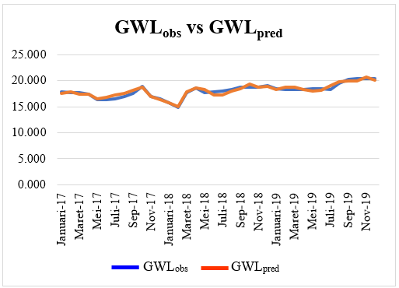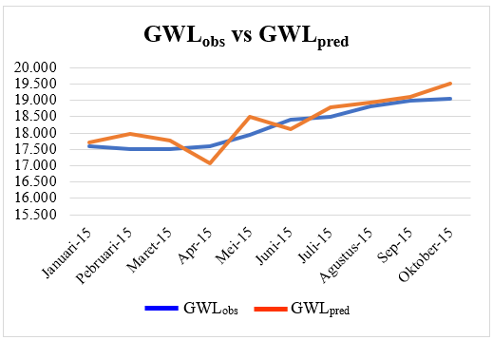
Figure 9. GWLobs and GWLpred in calibration stage (4-4-1 ; Ubung well) Figure 10. GWLobs and GWLpred in verification stage (4-4-1 ; Ubung well)
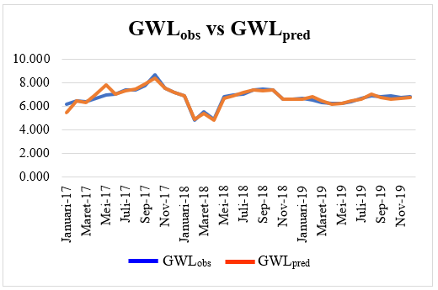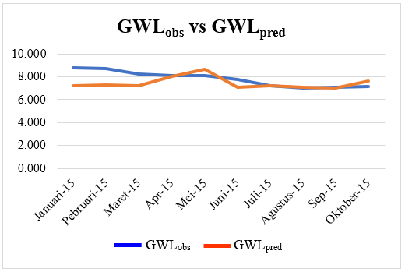
Figure 11. GWL_{obs} and GWL_{pred} in calibration stage (7-14-1 ; Ngurah Rai well) Figure 12. GWL_{obs} and GWL_{pred} in verification stage ((7-14-1 ; Ngurah Rai well)

3. Conclusion
The purpose of this study was to predict groundwater level fluctuation at two monitoring well in Denpasar (Ubung and GOR Ngurah Rai) obtained from hydrometeorology data such as barometric pressure, evaporation, temperature, humidity, wind speed, and bright sunshine by using two different modelling methods. The models compared in this study are multiple linear regression (MLR) and artificial neural network (ANN) models. The developed model has three-layer structures: one input layer with four and seven neurons, one hidden layer with four, seven, eight, and fourteen neurons and one output layer. Logistic sigmoid (logsig) and linear transfer function (purelin) were used in the hidden and output layers as activation functions for the ANN method. The training algorithm used was gradient descent with momentum and adaptive learning rate (traingdx).
Barometric pressure, evaporation, temperature, humidity, wind speed, and bright sunshine were used as input parameters to predict groundwater level fluctuation. In the MLR model, the hydrometeorology parameter was filtered by quality data test: a consistency test, trend absence test, outlier test, stationary, and persistence test. MLR model results for Ubung wells obtained an R2 value of 0.606, and for GOR Ngurah Rai well got an R2 value of 0.257. While based on the ANN model, the value of R2 was obtained by 0.912 for the Ubung well and R2 of 0.9133 for the GOR Ngurah Rai well. When results of LR and ANN were compared, it saw that the ANN modelling approach gives more accurate results for all predicted parameters. It means MSE, RMSE, and MAE values of the ANN model were less than MLR. Ubung monitoring wells obtained an MSE value of 0.6325, RMSE of 0.7953, MAE of 0.6122 based on the MLR model, while ANN models got an MSE value of 0.143; RMSE is 0.379, and MAE is 0.311. For the GOR Ngurah Rai monitoring, well-obtained MSE value of 1.3406, RMSE of 1.1579, and MAE value of 0.9152, while for ANN models obtained MSE value of 0.0483, RMSE of 0.2198, and MAE of 0.1266
Based on the results of modelization of multiple linear regression and artificial neural network obtained, the artificial neural network model is superior to the multiple linear regression models. In general, the groundwater level fluctuation prediction model with the Artificial Neural Network provides an excellent correlation value in Ubung monitoring wells and GOR Ngurah Rai monitoring wells. However, at GOR Ngurah Rai, monitoring wells provide low correlation values at the verification or testing stage. It can also be concluded that the artificial neural network model to predict groundwater level fluctuation offers the advantage of being fast, accurate and reliable. There is also a significant simplicity in using ANN due to its power to deal with multivariate and complicated problems.

REFERENCES
[1] Coulibaly, P., Anctil, F., Aravena, R., Bobée, B., "Artificial neural network modeling of water table depth fluctuations," Water Resources Research, vol. 37, no. 4, pp. 885–896, 2007. DOI: 10.1029/2000WR900368.
[2] Nikolos, I.K., Stergiadi, M., Papadopoulou, M.P., Karatzas, G.P., "Artificial neural networks as an alternative approach to groundwater numerical modelling and environmental design," Hydrological Processes, vol. 22, pp. 3337–3348, 2007. DOI: 10.1002/hyp.6916.
[3] Taylor, C.J., Alley, W.M., "Monitoring and the Importance of Long-Term Water-Level Data," U.S. Geological Survey, 2001.
[4] Todd, D.K., Mays, L.W., "Groundwater Hydrology," 3rd ed, John Wiley & Sons, Inc, 2005.
[5] Sahoo, S., Jha, M.K., "On the statistical forecasting of groundwater levels in unconfined aquifer systems," Environmental Earth Sciences, vol. 73, no. 7, pp. 3119–3136, 2007. DOI: 10.1007/s12665-014-3608-8.
[6] Makridakis, S.G., Wheelwright, S.C., Hyndman, R.J., "Forecasting: Methods and Applications", Wiley, 1998.
[7] Adeloye, A.J., "Multiple Linear Regression and Artificial Neural Networks Models for Generalized Reservoir Storage–Yield–Reliability Function for Reservoir Planning," Journal of Hydrologic Engineering, vol. 14, no. 7, pp. 731–738, 2007. DOI: 10.1061/(asce)he.1943-5584.0000041.
[8] Hodgson, F.D.I., "The Use of Multiple Linear Regression in Simulating Ground‐Water Level Responses," Ground Water, vol. 16, no. 4, pp. 249–253, 2007. DOI: 10.1111/j.1745-6584.1978.tb03232.x.
[9] Shao, Q., Campbell, N.A., "Modelling trends in groundwater levels by segmented regression with constraints," Australian and New Zealand Journal of Statistics, vol. 44, no. 2, pp. 129–141, 2007. DOI: 10.1111/1467-842X.00216.
[10] Daliakopoulos, I.N., Coulibaly, P., Tsanis, I.K., "Groundwater level forecasting using artificial neural networks," Journal of Hydrology, vol. 309, nos. 1–4, pp. 229–240, 2007. DOI: 10.1016/j.jhydrol.2004.12.001.
[11] Lallahem, S., Mania, J., Hani, A., Najjar, Y., "On the use of neural networks to evaluate groundwater levels in fractured media," Journal of Hydrology, vol. 307, nos. 1–4, pp. 92–111, 2007. DOI: 10.1016/j.jhydrol.2004.10.005.
[12] Nayak, P.C., Satyaji Rao, Y.R., Sudheer, K.P., "Groundwater level forecasting in a shallow aquifer using artificial neural network approach," Water Resources Management, vol. 20, no. 1, pp. 77–90, 2007. DOI: 10.1007/s11269-006-4007-z.
[13] Affandi, A.K., Watanabe, K., Tirtomihardjo, H., "Application of an artificial neural network to estimate groundwater level fluctuation," Journal of Spatial Hydrology, vol. 7, no. 2, pp. 17–32, 2007.
[14] Krishna, B., Rao Y.R.S, Vijaya, T., "Modelling groundwater levels in an urban coastal aquifer using artificial neural networks," Hydrological Processes, vol. 22, pp. 1180–1188, 2007. DOI: 10.1002/hyp.6686.
[15] Sethi, R.R., Kumar, A., Sharma, S.P., Verma, H.C., "Prediction of water table depth in a hard rock basin by using artificial neural network," International Journal of Water Resources and Environmental Engineering, vol. 2, no. 4, pp. 95–102, 2007.
[16] Ardana, P.D.H., Redana, I.W., Yekti, M.I., Simpen, I.N., "Prediction of Groundwater Level in the Shallow Aquifer Using Artificial Neural Network Approach," IOP Conference Series: Earth and Environmental Science, vol. 837, no. 1. DOI: 10.1088/1755-1315/837/1/012010.
[17] Uddameri, V., "Using statistical and artificial neural network models to forecast potentiometric levels at a deep well in South Texas," Environmental Geology, vol. 51, no. 6, pp. 885–895, 2007. DOI: 10.1007/s00254-006-0452-5.
[18] Sahoo, S., Jha, M.K., "Groundwater-level prediction using multiple linear regression and artificial neural network techniques: A comparative assessment," Hydrogeology Journal, vol. 21, no. 8, pp. 1865–1887, 2007. DOI: 10.1007/s10040-013-1029-5.
[19] BPS Kota Denpasar, "Kota Denpasar Dalam Angka 2020 [Denpasar City in 2020 Figures]," Badan Pusat Statistik Kota Denpasar, 2020.
[20] Sudadi, P., Setiadi, H., Denny, B.R., Arief, S., Ruchijat, S., Hadi, S., "Peta Hidrogeologi Lembar Pulau Bali [Hydrogeological Map of Bali Island Sheet]," Direktorat Tata Lingkungan Geologi dan Kawasan Pertambangan Sub. Direktorat Pendayagunaan Air Tanah, 1986.
[21] Anonim, "Laporan Akhir Pekerjaan Pembuatan Peta Zonasi Pemanfaatan Air Tanah Provinsi Bali Tahun Anggaran 2014 [Final Report on Zoning Work for Groundwater Utilization of Bali Province in Fiscal Year 2014]," Dinas Pekerjaan Umum Provinsi Bali, 2014.
[22] Purbo-Hadiwidjojo, M.M., Samodra, H., Amin, T.C., "Peta Geologi Lembar Bali, Nusa Tenggara [Geological Map of Bali, Nusa Tenggara]," Pusat Penelitian dan Pengembangan Geologi, 1998.
[23] Soewarno, "Analisis Data Hidrologi Menggunakan Metode Statistik Dan Stokastik [Analysis of Hydrological Data Using Statistical and Stochastic Methods]," Graha Ilmu, 2015.
[24] Chow, V. Te, Maidment, D.R., Mays, L.W., "Applied Hydrology," McGraw-Hill Book Company, 1988.
[25] Giacomino, A., Abollino, O., Malandrino, M., Mentasti, E., "The role of chemometrics in single and sequential extraction assays: A Review. Part II. Cluster analysis, multiple linear regression, mixture resolution, experimental design and other techniques," Analytica Chimica Acta, vol. 688, no. 2, pp. 122–139, 2007. DOI: 10.1016/j.aca.2010.12.028.
[26] Ghozali, I., "Aplikasi Analisis Multivariete Dengan Program IBM SPSS 23 [Multivariete Analysis Application With IBM SPSS 23 Program]," 8th ed, Badan Penerbit Universitas Diponegoro, 2016.
[27] Haykin, S., "Neural Networks - A Comprehensive Foundation," 2nd ed, Prentice Hall, 2005.
[28] Ardana, P.D.H., Sudika, I.G.M., Astariani, N.K., Sumarda, G., "Application of Feed Forward Backpropagation Neural Network in Monthly Rainfall Prediction," International Journal of Advanced Trends in Computer Science and Engineering, vol. 8, no. 3, pp. 195–200, 2007.
[29] Ozgoren, M., Bilgili, M., Sahin, B., "Estimation of global solar radiation using ANN over Turkey," Expert Systems with Applications, vol. 39, no. 5, pp. 5043–5051, 2007. DOI: 10.1016/j.eswa.2011.11.036.
[30] Sugiyono, "Metode Penelitian Kuantitatif, Kualitatif Dan R&D [Quantitative, Qualitative and R&D Research Methods]," Alfabeta, 2017.
[31] Ardana, P.D.H., Redana, I.W., Yekti, M.I., Simpen, I.N., "A Bibliometric Analysis of Input Parameter in Artificial Neural Network Approach for Groundwater Level Prediction," International Journal of Engineering and Emerging Technologychnology, vol. 5, no. 2, pp. 131–136, 2007.

